What Makes A Typhoon Spin?
Tieh-Yong Koh
School of Physical & Mathematical Sciences, Nanyang Technological University, 1 Nanyang Walk, Singapore 637616, Singapore.
Email: kohty@ntu.edu.sg

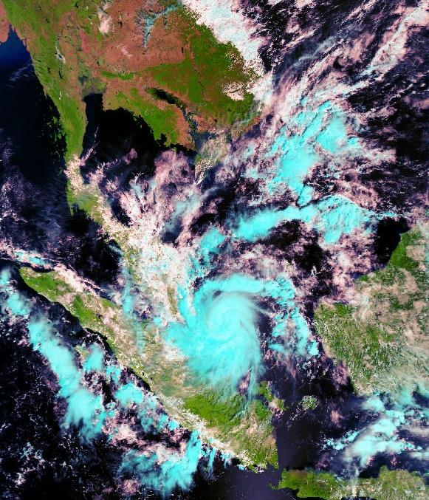
Typhoon Vamei on 27 Dec 2001 (11:32am, Singapore Time)
MODIS-TERRA satellite picture with courtesy from Centre for Remote Imaging, Sensing and Processing (CRISP), NUS

On 27 Dec 2001, typhoon Vamei landed on the southern tip of the Malay Peninsula, bringing heavy rain and widespread flooding in the southern Malaysian state of Johor and nearby Singapore. Trees that had otherwise been sturdy were uprooted with little mercy. While similar rotating tropical storms are no strangers in Asia and Oceania, the occurrence of Vamei at equatorial latitudes of 1.5 degrees north was unheard of before. The eye of the cyclone developed a mere 150km east of Singapore! Confronted with such awesome natural forces right at our doorstep, we cannot help but ponder on their nature and ask a very simple but compelling question, “What makes a typhoon spin (so terribly)?”

The atmosphere, like any other fluid, is governed by a few fundamental principles in Physics: the Principle of Mass Conservation, the First Law of Thermodynamics and Newton’s Second Law. Thus, one can write down a set of differential equations for the atmosphere and solve for the atmosphere’s behaviour. In this sense, weather forecasting is not so different from solving for the simple harmonic motion of a swinging pendulum, except that the equations are mathematically harder to solve and we use computers to solve them numerically. Now, the weather is a chaotic system, which means that errors in the numerical solutions tend to grow exponentially fast. So to ensure that the solutions (i.e. computer simulations) remain realistic, we use statistical methods to incorporate observational data from time to time and obtain the “best guess” of the atmospheric state.

In this way, is the problem solved? Yes and no. Yes, because we have a mathematical model of the atmosphere in our hands. No, because we still have not answered the question, “What makes a typhoon spin?” For that, we need to analyze our numerical solutions carefully and apply the physical concept of Angular Momentum Conservation. Only then, we can begin to understand where the rotation in the air comes from...

